**BOP**

**MINI - PROJECT**



**Subject: Flight Reservation System**

Members:

Ayan Neel Medhi (20102885)

Mannur Maheshwar Reddy (20102458)

Piyush Rohan (20102835)

Saurav Das (20102333)

Shubhangi Agarwal (20102758)

Suchi Pragyan Rout (20102336)

Sutrave Kumar Datta (20102756)

Tarun Pratap Singh (20102416)

**WeBOP Flight Ticket Booking Service – BOP Mini Project**

**SYNOPSIS –**

This is an online flight reservation system. This website allows a user to search for existing flights and book the same, after signing up (first-time users) or logging in (registered users). The user can also avail the provision of viewing or cancelling the booked flight. The admin can log in directly using pre-registered credentials for administrator controls.

The landing page of the website will display a search form in which the user can input his/er route requirement, as well as the number of bookings to be done and the date of journey. Upon submitting, the available flights of the route will be displayed, from which the user can select any one. Before proceeding, he/she will be prompted to log in. They would then be asked to fill the passengers’ details, and upon submission, would be assigned their PNR number.

The landing page will also have the provision of viewing/cancelling pre-booked tickets. The user can input their PNR number in the Flight Status or Manage Bookings tabs in the landing page for viewing or cancelling their tickets, respectively.

The admin will be required to log-in through the login modal form available at the landing page, using pre-registered credentials. S/He will be able to view, edit, add or delete flights and their respective attributes.

**OBJECT BEANS:**

**Passenger –**

It is a class, the object of which will be accessed by the respective Dao class and the changes in attribute values will be reflected in the ‘passenger_details’ Table.

* Passenger ID
* Password
* First Name
* Last Name
* Phone Number
* Email ID
* Age

**Admin –**

It is a class, the object of which will be accessed by the respective Dao class and the changes in attribute values will be reflected in the ‘admin_details’ Table. The ‘name’ data member will hold the Email ID of the admin, required for logging in.

* Name
* Password

**Flight –**

It is a class, the object of which will be accessed by the respective Dao class and the changes in attribute values will be reflected in the ‘flight’ Table. Its object would be used for modifying the admin influenced changes in the flights database.

* Ticket ID
* Flight ID
* Flight Departure Time
* Status
* Source
* Destination
* Email ID
* Flight Arrival Time
* Phone Number
* Ticket Date
* Passenger ID
* Passenger Names
* Total Price

**Flight Detail –**

It is a class, the object of which will be accessed by the respective Dao class and the changes in attribute values will be reflected in the ‘flight’ Table. Its object is used by a user while searching for a flight as per their requirements.

* Flight Departure Time
* Status
* Source
* Destination
* Email ID
* Ticket ID
* Flight ID

**Ticket –**

It is a class, the object of which will be accessed by the respective Dao class and the changes in attribute values will be reflected in the ‘ticket_info’ Table. It will be used when the user wants to view or cancel the ticket.

* Ticket ID
* Flight ID
* Flight Departure Time
* Status
* Source
* Destination
* Email ID
* Flight Arrival Time
* Phone Number
* Ticket Date
* Passenger ID
* Passenger Names
* Total Price

**Date –**

It is a class, the object of which will be accessed by the respective Dao class, the values of which are used to create tables for flights on respective date.

* Date ID
* Date

**TABLES AND ATTRIBUTES**

**Flight –**

* Flight ID (Number)
* From Location(Varchar)
* To Location (Varchar)
* Duration (Float)
* Total Seats (Number)
* Distance (Float)
* Departure Time (Varchar)
* Arrival Time (Varchar)
* Price (Number)

**Date Info –**

* New (Date)
* Date ID (Varchar)

**Ticket Info –**

* Ticket ID (Number)
* Flight ID (Number)
* Status(Varchar)
* Pass ID (Number)
* Pass Names (Varchar)
* T Date (Date)
* Flight Dep Time(Varchar)
* From Location (Varchar)
* To Location(Varchar)
* Arr Time (Varchar)
* Total Price (Number)
* Phone No (Number)
* Email ID (Varchar)
* Age (Varchar)

**Admin –**

* Admin ID (Varchar)
* PWD (Varchar)

**Passenger Details –**

* Password(Varchar)
* First Name (Varchar)
* Last Name(Varchar)
* Phone No (Number)
* Email ID (Varchar)
* Pass ID (Number)

**SCREEN CAPTURES OF THE USER INTERFACE:**

This is the home page of the website where customers can search flights for their route, view or cancel their flights. A new user can also register through the signup option available.

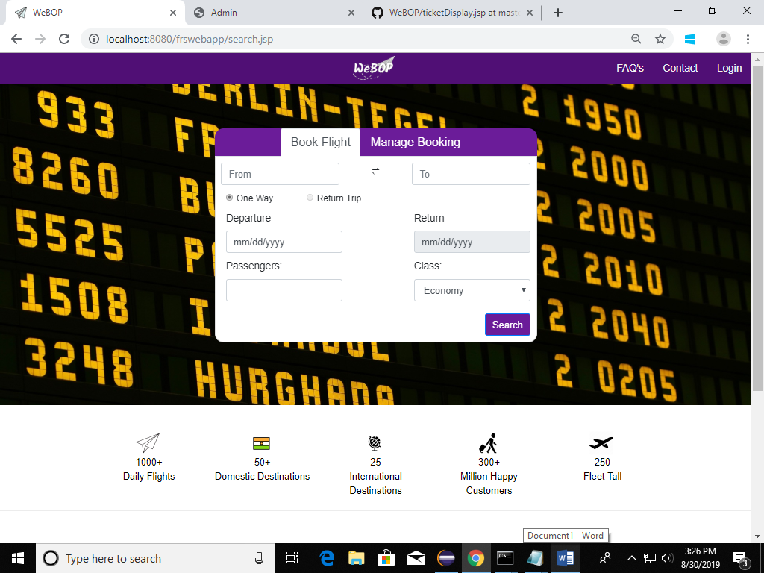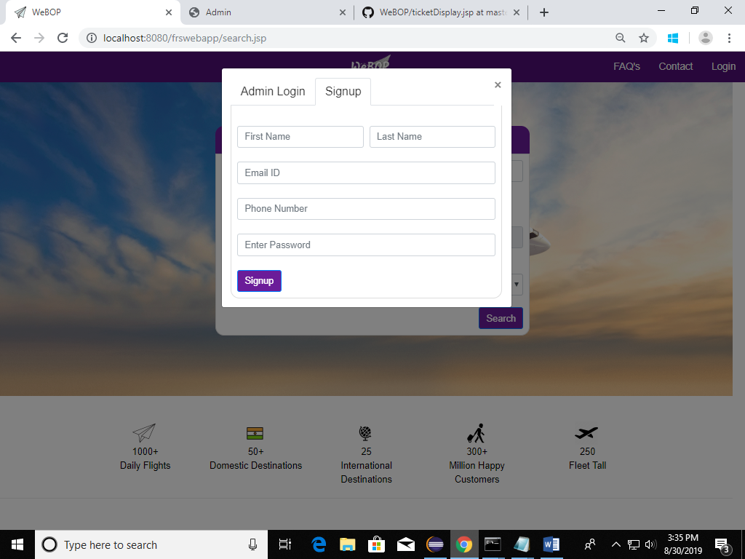

They can also access the FAQ’s and Contacts page from the home page.

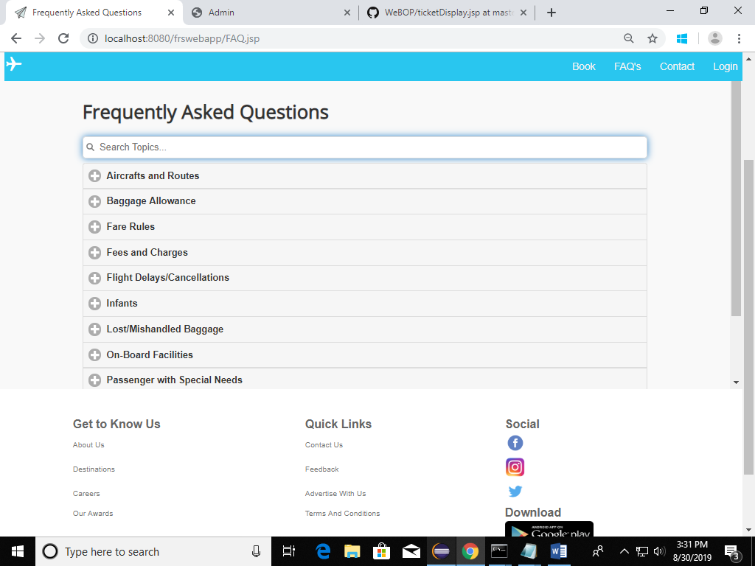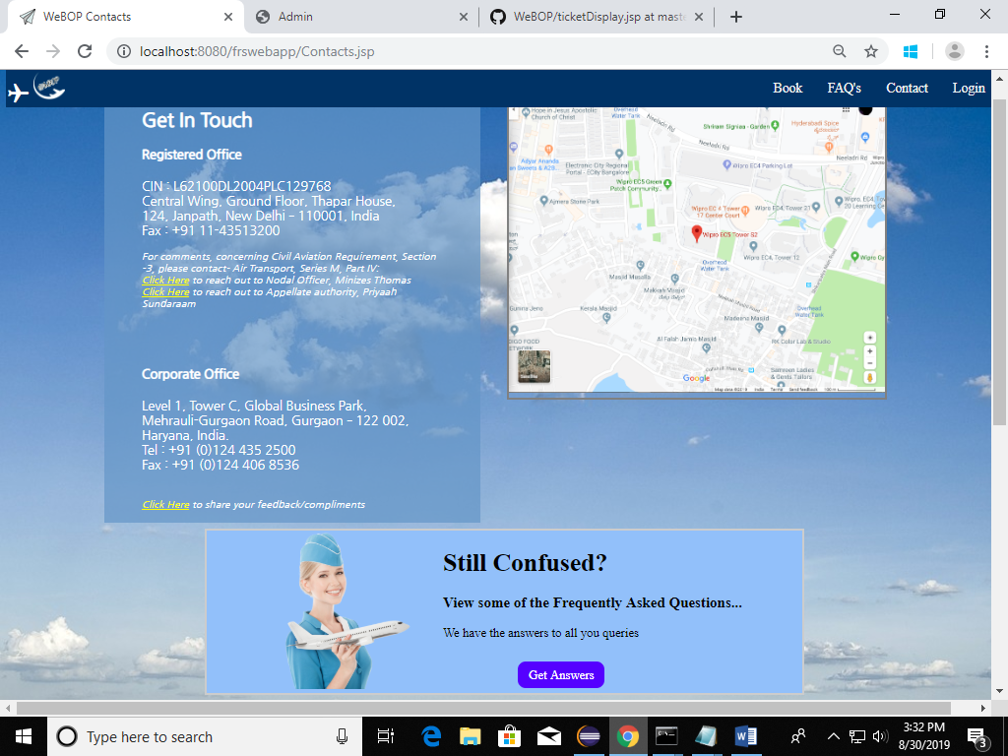

Upon searching, it will the show the available flights for the route. If no flights are available then it will redirect to the landing page.

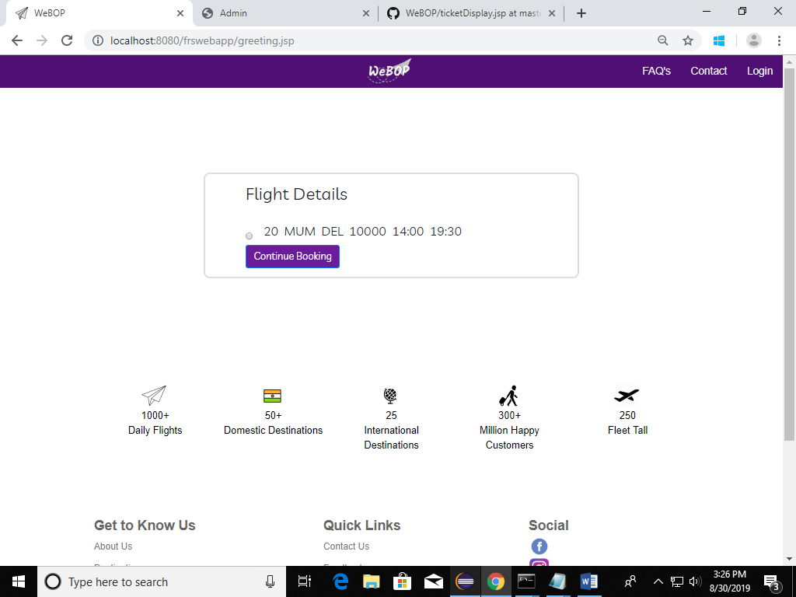

Pre-existing users can input their credentials to log in to the system.

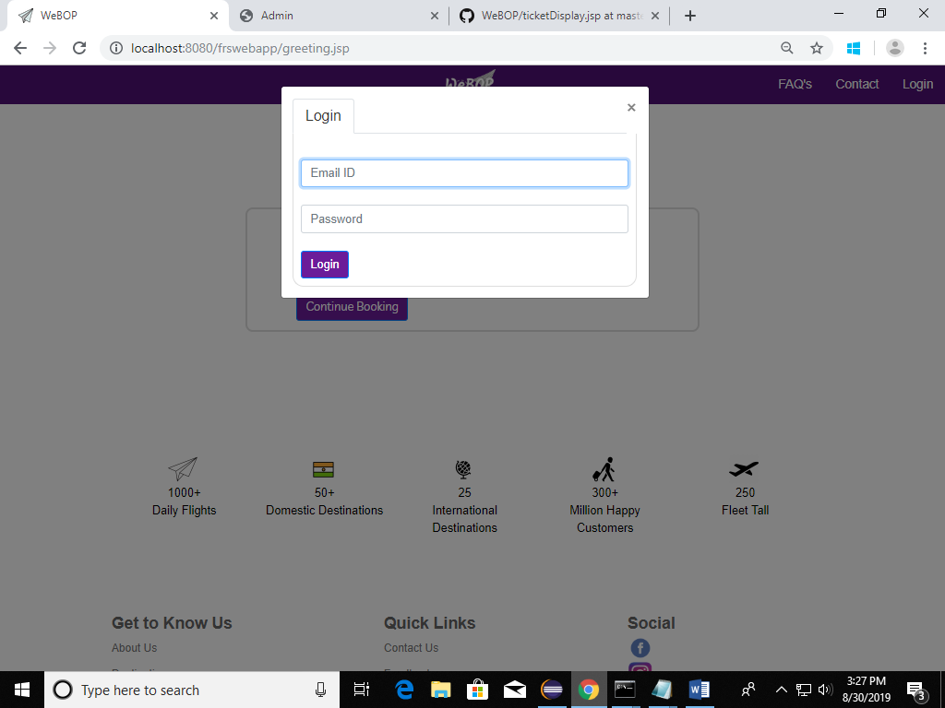

This page will ask for the names and ages of all the passengers for whom the flight is to be booked.

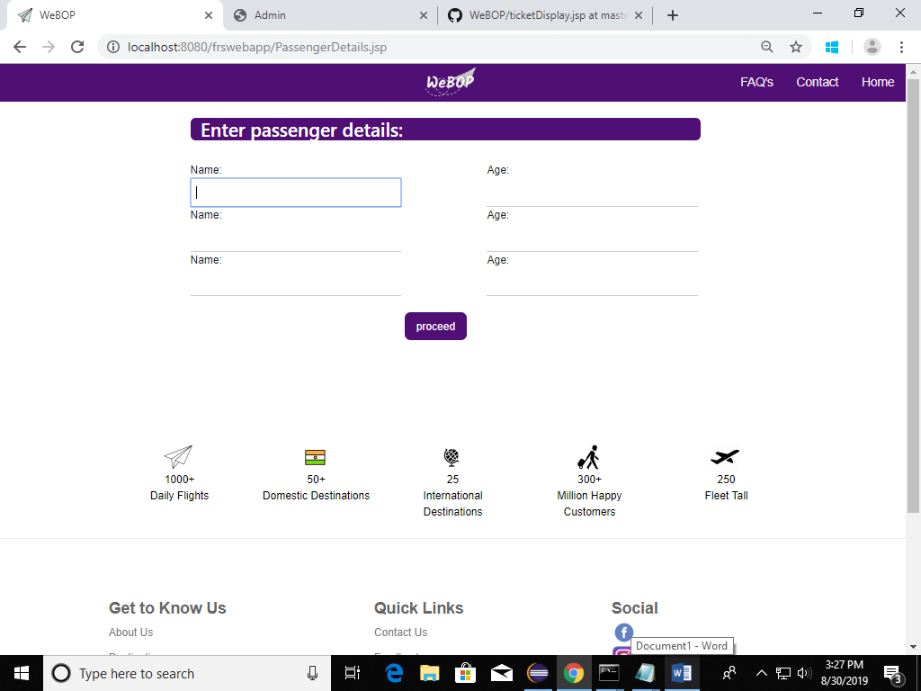

It will display confirmation of ticket booking along with respective PNR Number.

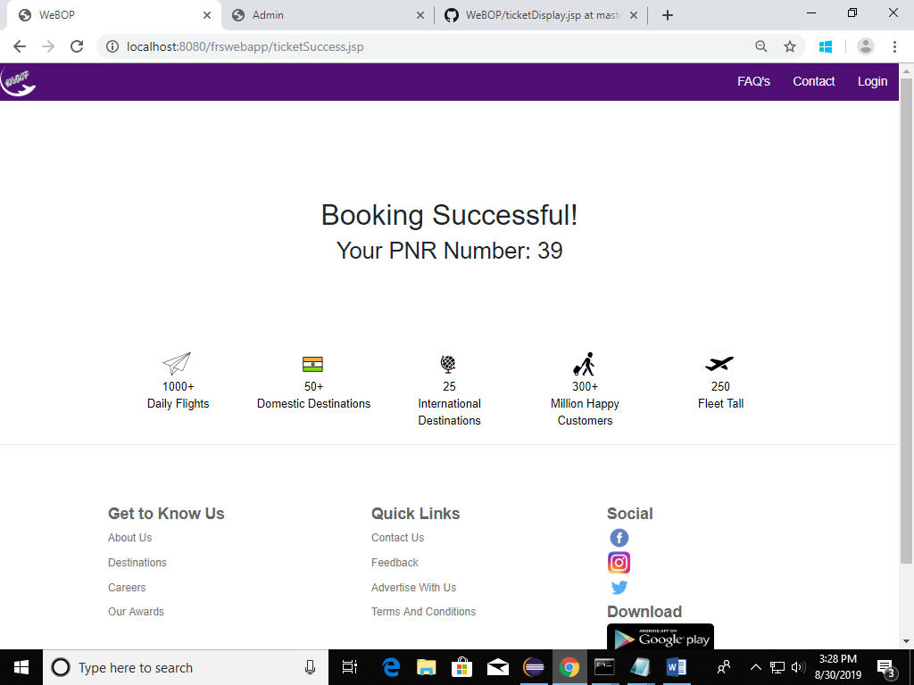

It will display the flight route according to input PNR.

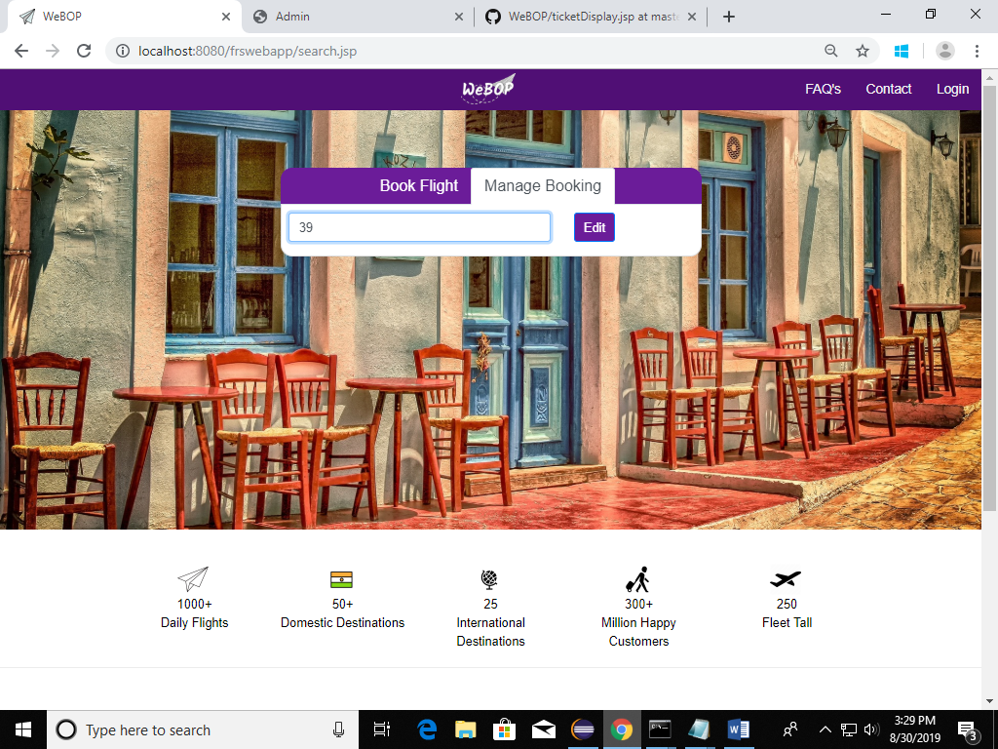

It will provide details of the flight according to PNR and give the option to cancel the booking. If the ticket is confirmed, the status will show Confirmed, otherwise it will show Cancelled and the user can redirect back to the home page.

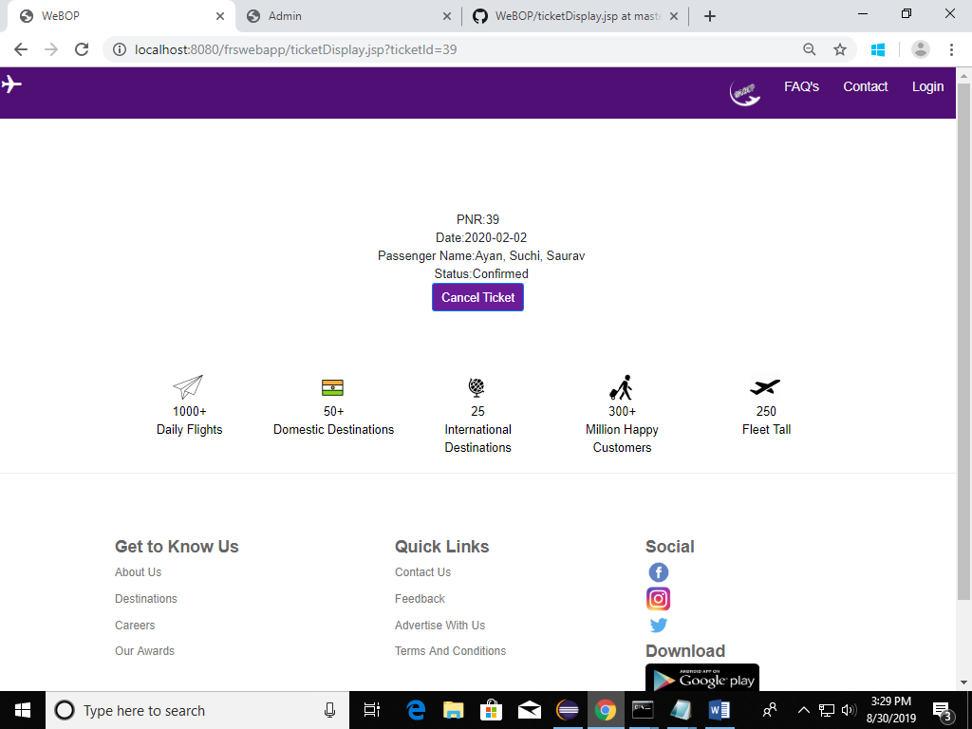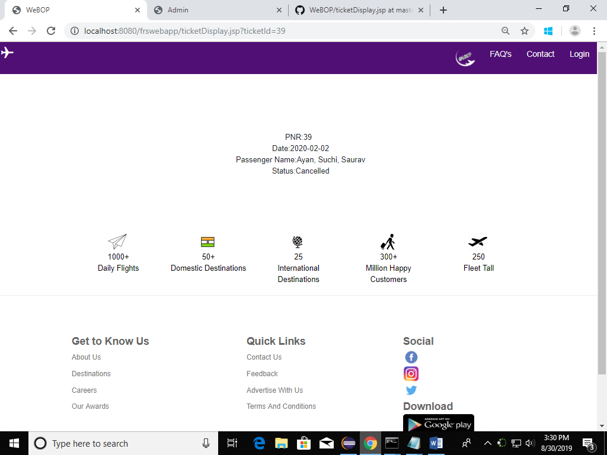

Admin can log in at the home page itself.

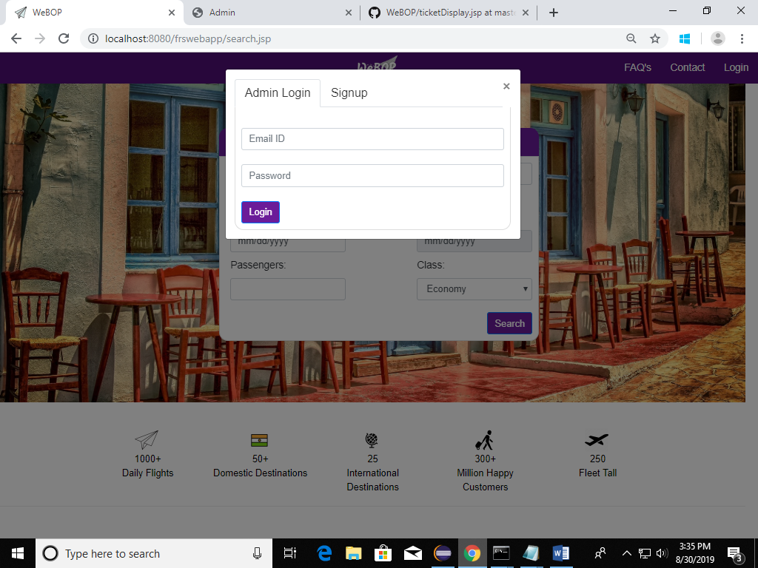

Upon logging in, flight details will be displayed to the admin.

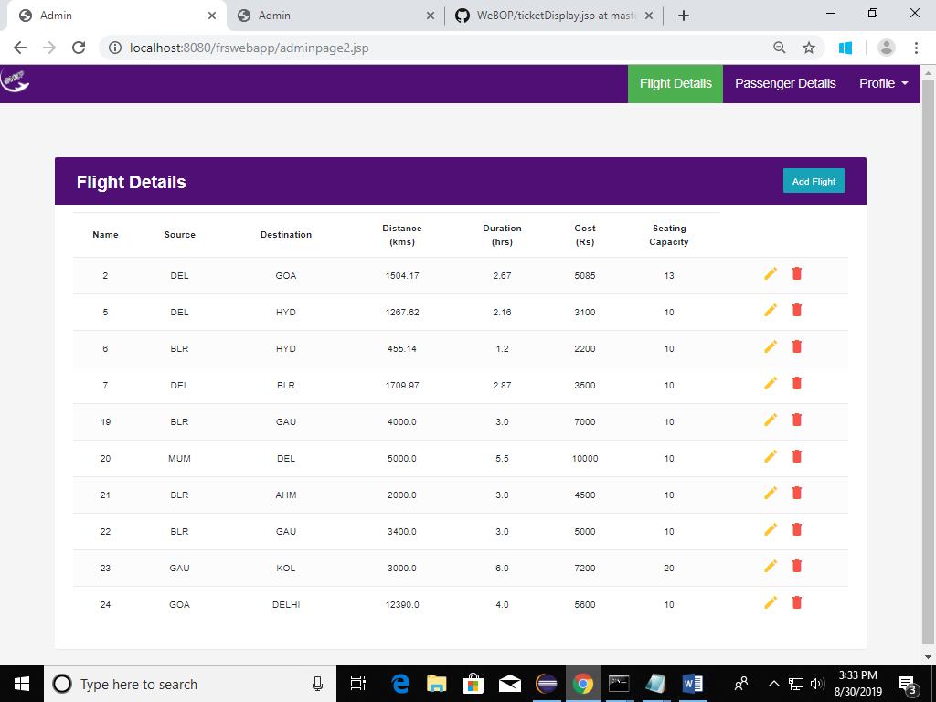

There is also the provision to display the Passenger details to the admin.

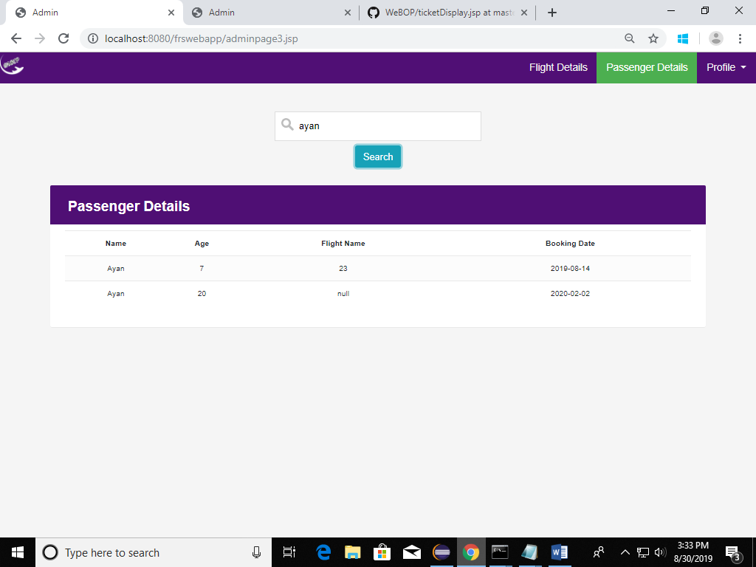

The admin can add, edit or delete a flight and its details, as shown below.

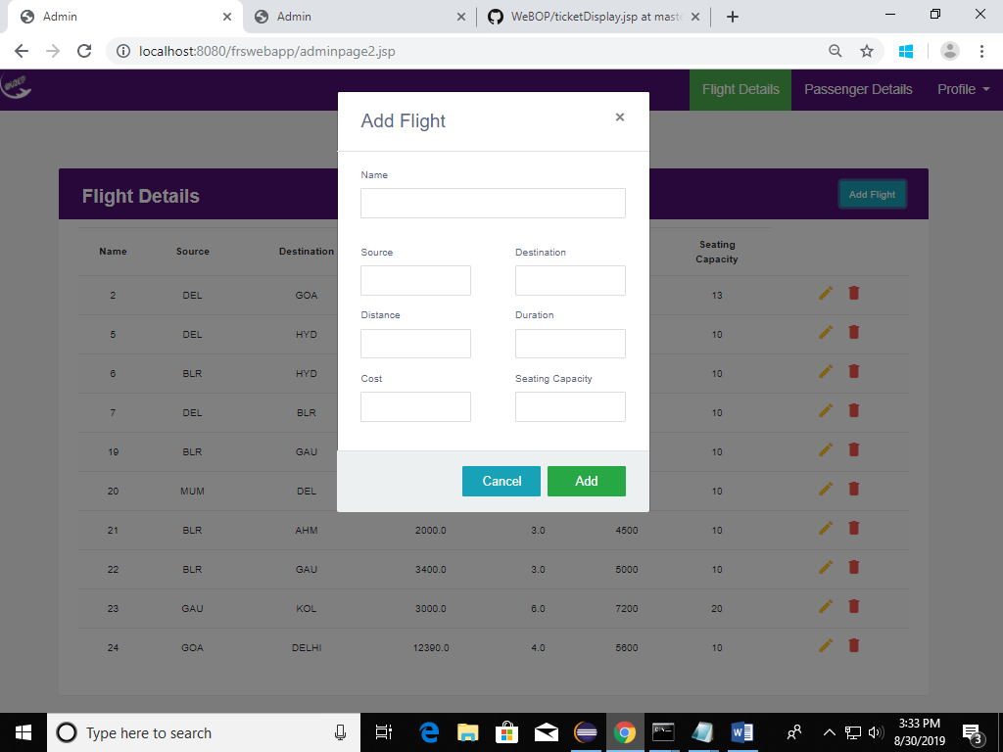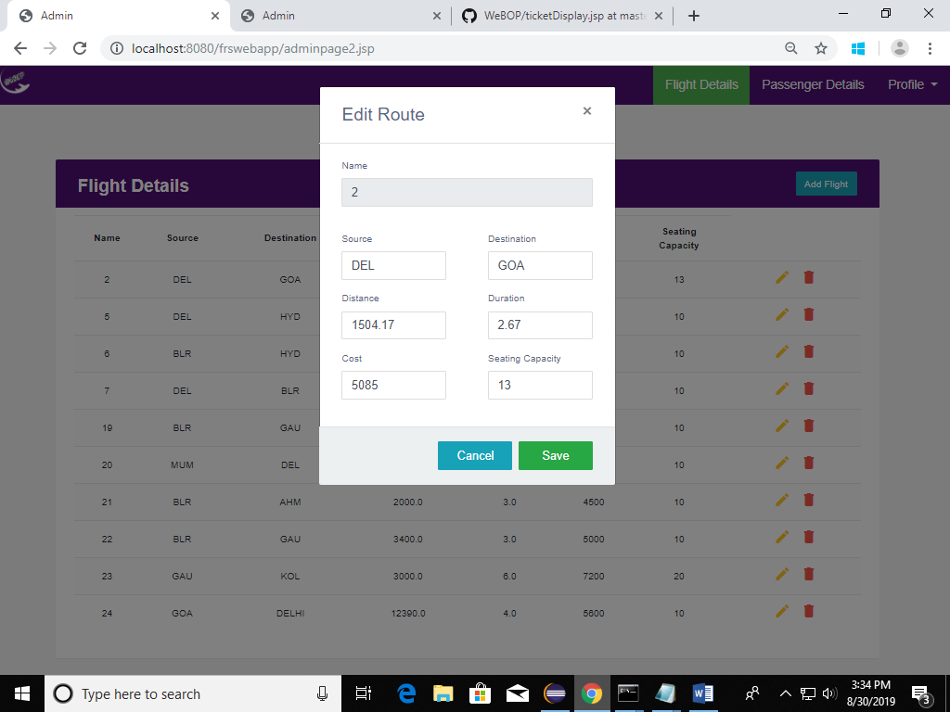

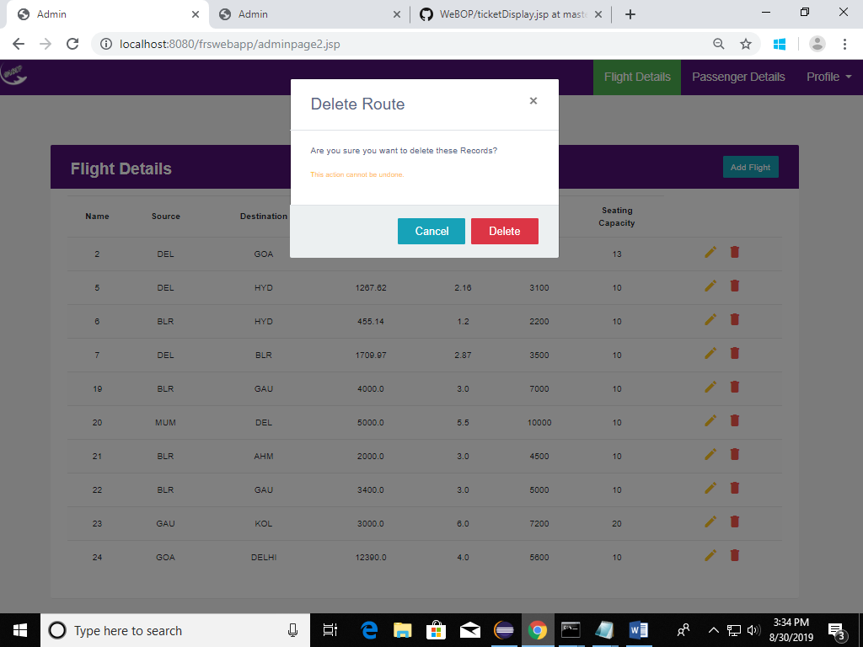

The admin can change his/er password.

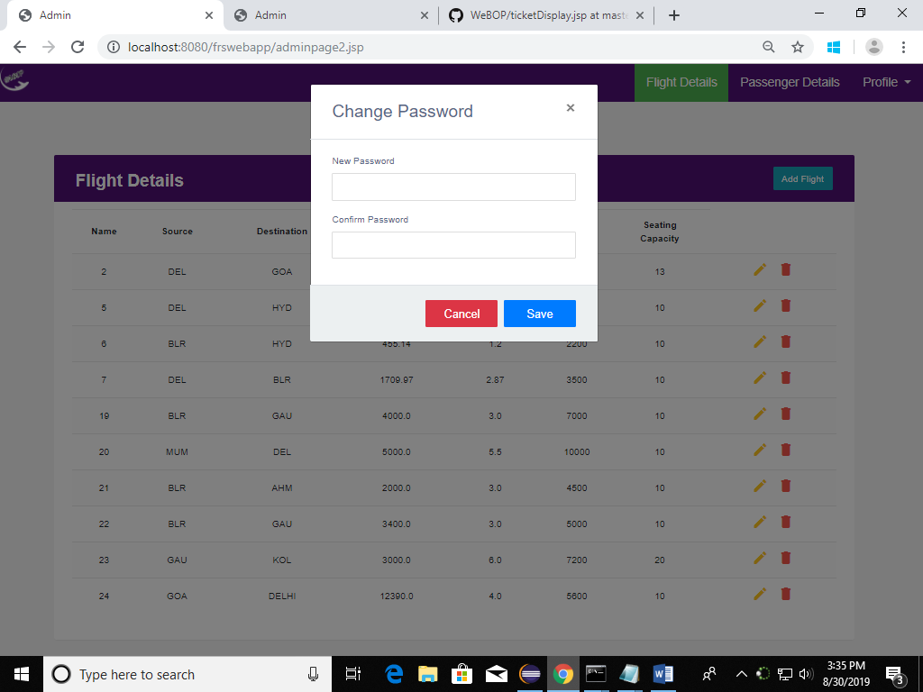

Upon logging out, admin will be redirected to the home page.

